River Severn, Buildwas 2 stretch, left bank from top of island downstream to gardens above Meadow Inn

.

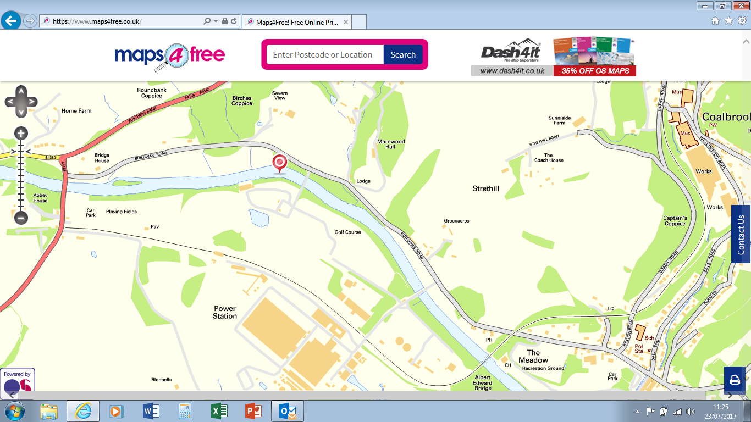

Parking

Parking

End

Start